**Amazon Products Optimal Price Prediction**

**Team 17:**

Ananthakrishna Kalle & Vaishnavi Yadamreddy

**Project Description**

**Background:**

Amazon is a massive marketplace with a broad selection of products in the vast and dynamic world of e-commerce. Understanding consumer behavior and market trends is critical to the success of this platform. The Amazon Products Dataset (2023), which includes more than 1.4 million products, is a priceless tool for learning about consumer preferences and market dynamics. This dataset has enormous potential for use in market analysis and predictive modeling, and it can help firms and scholars understand and anticipate e-commerce trends.

**Motivation:**

The primary motivation behind analyzing the Amazon Products Dataset is to leverage big data to gain insights into market dynamics. The dataset is a goldmine for understanding how different products perform, which categories are most popular, and what pricing strategies might be most effective. For businesses and retailers, these insights are invaluable for strategizing and optimizing their product offerings and pricing models to meet consumer demand and stay competitive.

**Goal:**

Our project's goal is to create an advanced tool that can forecast market trends and product popularity by analyzing the Amazon Products Dataset. In order to forecast sales, spot new market trends, and give sellers and companies useful information, this tool will make use of machine learning algorithms. The ultimate objective is to provide a platform that supports understanding the dynamics of e-commerce markets and helping make data-driven decisions.

**Data Analysis:** Performing a thorough exploratory data analysis (EDA) to understand the dataset's structure, content, and the relationships between different variables.

**Predictive Modeling:** Utilizing machine learning algorithms to build predictive models that can forecast market trends, product demand, and price fluctuations.

**Market Insights:** Drawing actionable insights that can inform strategic business decisions, such as inventory management, marketing campaigns, and customer segmentation.

**Trend Forecasting:** Identifying emerging trends in consumer behavior and preferences, which can be used to predict future market shifts.

**Sentiment Analysis:** Analyzing customer reviews to gauge public sentiment towards products, which can influence product development and marketing strategies.

**Methodology**

**1. Data Collection and Preparation:** Explore the dataset to understand detailed information on 1.4 million products available on Amazon.Prepare the data for model training by organizing it into appropriate directories or data frames.

**2. Data Preprocessing:** The dataset will undergo rigorous cleaning and preprocessing, including handling missing values, normalizing features, and encoding categorical data. We will also create new features that might be relevant for our analysis, such as product category popularity, average review score, etc.

a. **Preprocessing with TF-IDF:**

**Purpose:** Converts text to numerical data, highlighting the uniqueness of words across documents.

**Use Case:** Ideal for feature extraction from product descriptions or reviews, aiding in sentiment analysis or price prediction.

b. **Preprocessing with Count Vectorizer:**

**Purpose:** Creates a feature matrix with word frequencies from the text data.

**Use Case:** Good for feature extraction where the frequency of words may indicate the product's category or popularity.

**3. Exploratory Data Analysis (EDA):** We will conduct an in-depth analysis using statistical techniques to identify trends, correlations, and key factors influencing product popularity and customer satisfaction.

**4. Feature Engineering:** Informed by the insights gained during EDA, we proceed to select and engineer features like discount percentage, rating score and price difference

**5. Machine Learning Algorithms:**

a. **Ridge Regression:**

**Purpose:** Tackles multicollinearity in regression models by adding a penalty to coefficient estimates.

**Use Case:** Best for predictive models where predictors are numerous and correlated, like price prediction based on various product attributes.

b. **Random Forest Regressor:**

**Purpose:** Averages predictions from multiple decision trees to improve accuracy and control overfitting.

**Use Case:** Suitable for complex regression tasks like predicting sales based on historical data patterns.

c. **Multinomial Naïve Bayes:**

**Purpose:** Performs classification by assuming feature independence and is especially good with discrete data.

**Use Case:** Effective in text classification, such as spam detection or categorizing products based on descriptions.

d. **Logistic Regression:**

**Purpose:** Estimates probabilities for binary outcomes and is a foundation for binary classification models.

**Use Case:** Useful for binary decisions, like predicting if a product will be a bestseller or not, based on features.

**Description of the Dataset**

The dataset from the Amazon products listing consists of two CSV files, one detailing categories and the other detailing product information. Below is a description of each:

**Categories Dataset:**

Two columns are present:

**Id:** The id is a numerical identifier for the category, and

**category_name:** category_name is a string describing the category

**Products Dataset:**

There are 11 columns covering various aspects of product listings:

**asin:** The unique Amazon Standard Identification Number for the product.

**title:** The title of the product listing.

**imgUrl:** The URL of the product image.

**productURL:** The URL to the product page on Amazon.

**stars:** The average customer review rating for the product.

**reviews:** The number of reviews the product has received.

**price:** The current price of the product.

**listPrice:** The original list price of the product.

**category_id:** A numerical identifier linking the product to one of the categories in the categories dataset.

**isBestSeller:** A boolean indicating whether the product is a bestseller.

**boughtInLastMonth:** An estimate of the quantity of the product purchased in the last month.

**Dataset Link:** <https://www.kaggle.com/datasets/asaniczka/amazon-products-dataset-2023-1-4m-products/data>

**Dataset Size:** 104 MB

**Results and Analysis**

1. **Data Read:**

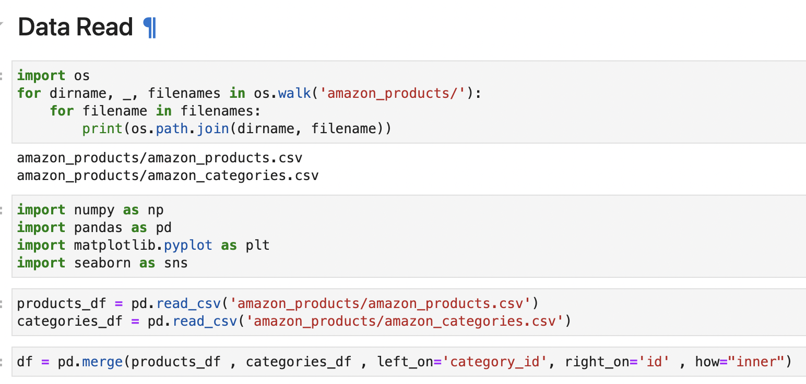

* In this step we have ‘os’ library to list files in the ‘amazon_products/’ directory, printing the paths of ‘amazon_products.csv’ and ‘amazon_categories.csv’.
* We have imported the basic python libraries for data analysis. Using the pandas library reading the csv files into pandas dataframes named ‘products_df’ and ‘categories_df’.
* Using ‘pd.merge()’ function combined the dataframes based on the category details into ‘df’.

1. **Data Cleaning and Preparation:**

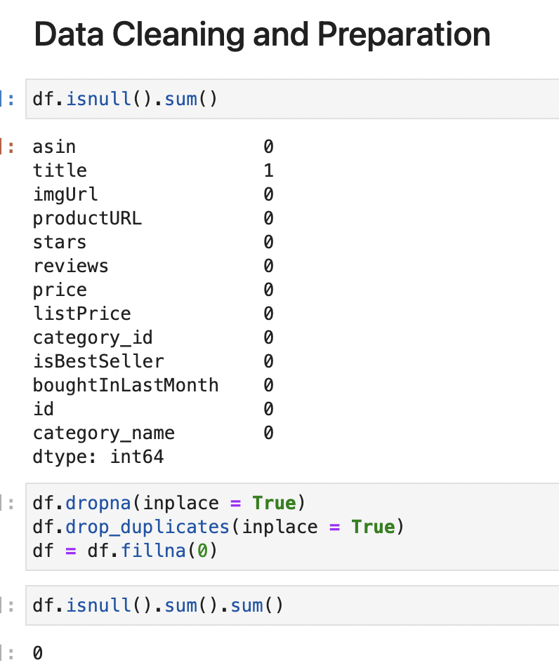 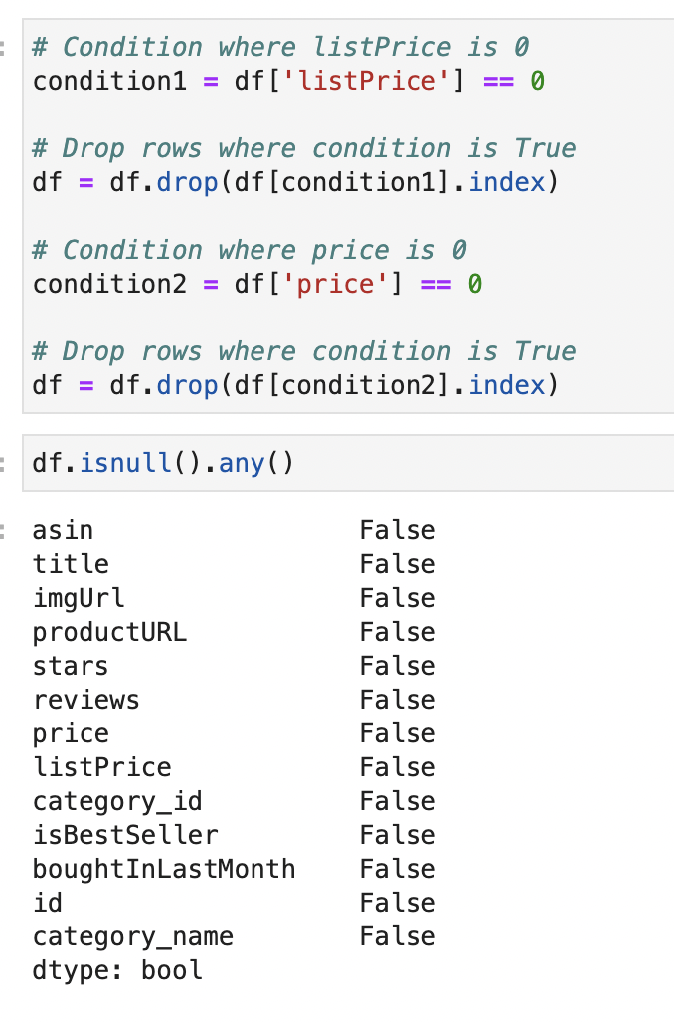

* ‘isnull().sum()’ method is called on dataframe ‘df’ to count the number of missing values in each column.
* Drop any rows with missing values ‘dropna()’ and duplicates ‘drop_duplicates()’, and fills in any remaining missing numerical values with 0 ‘fillna(0)’.
* ‘isnull().any()’ method confirms that there are no missing values left in any column, with all columns returning ‘False’.
* The removal of rows with a 'listPrice' or 'price' of 0 for data quality criterion specific to this analysis.

1. **Feature Engineering:**

**Discount Percentage:** A new column 'discount_percentage' is created by applying a function that calculates the discount percentage based on the list price and the actual price. Products with zero list prices are handled to avoid division by zero.

**Rating Categories:** It categorizes products into qualitative rating groups based on their 'stars' rating. This transforms a numeric rating into an ordinal categorical feature that can be used in machine learning models for classification or ordering.

**Price Difference:** Finally, a 'difference_price' column is created by subtracting the actual product price from the list price, which could be an indicator of the magnitude of discounts offered.

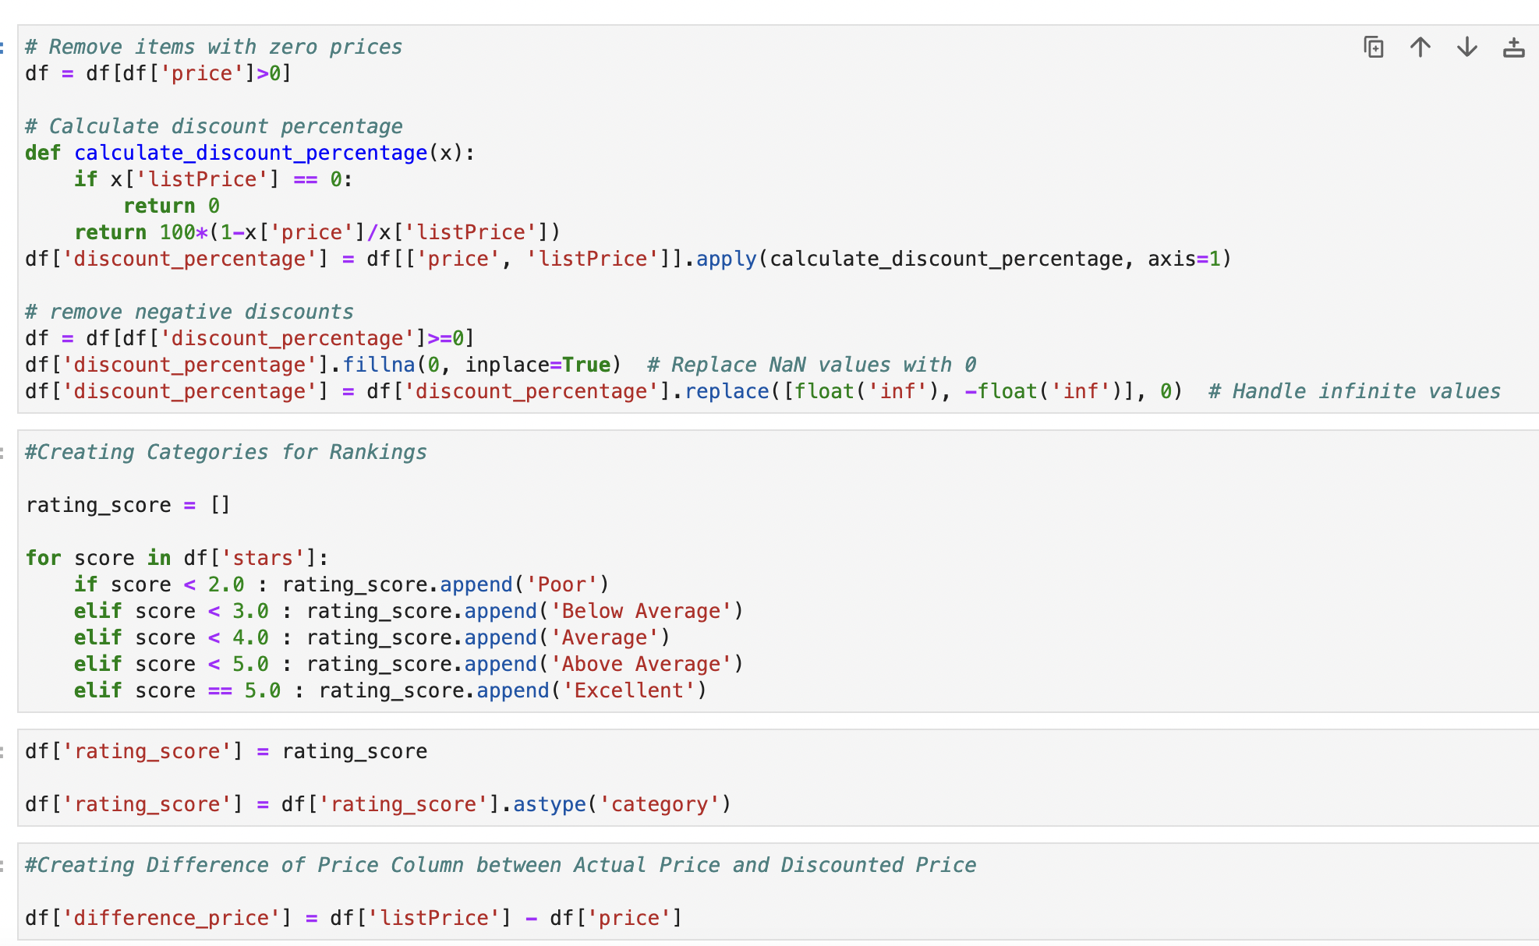

* Calculating ‘discount_percentage’ that helps in representing the distribution of discount percentages across various product categories that helps in analyzing the discount strategies across the different categories and category specific insights.
* Created categorical ratings based on the numerical ‘stars’ ratings that can be further used for machine learning model classification based on the ‘rating_score’
* Created ‘difference_price’ that is difference in price between the ‘listPrice’ and ‘price’ which is useful to us for data analysis and prediction.

1. **Exploratory Data Analysis (EDA):** We will conduct an in-depth analysis using statistical techniques to identify trends, correlations, and key factors influencing product popularity and customer satisfaction.

**Observation 1: Product Category**

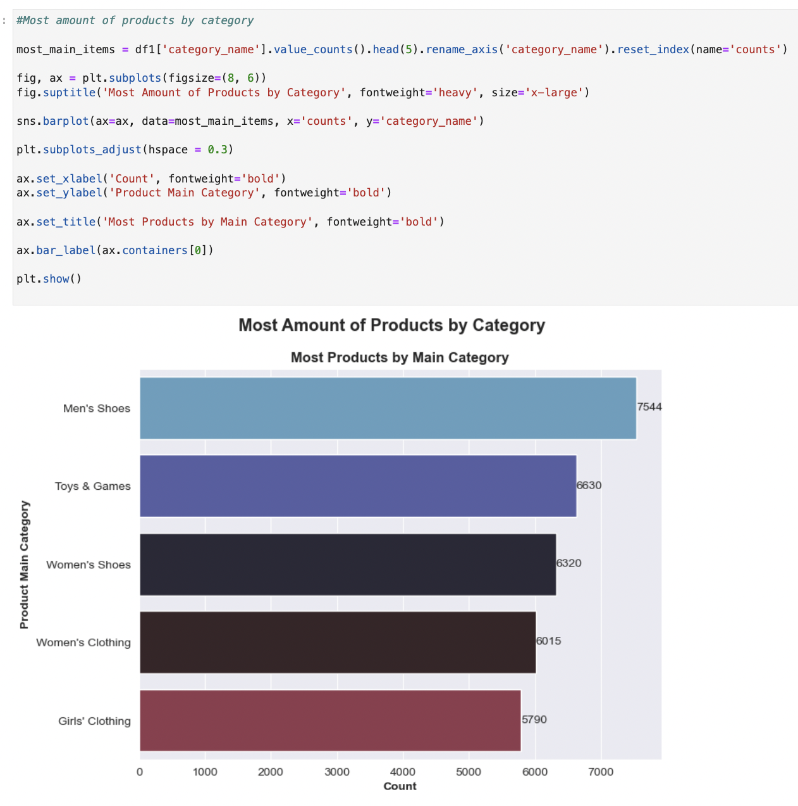

Fig: Top 5 Highest Number of Products by Category

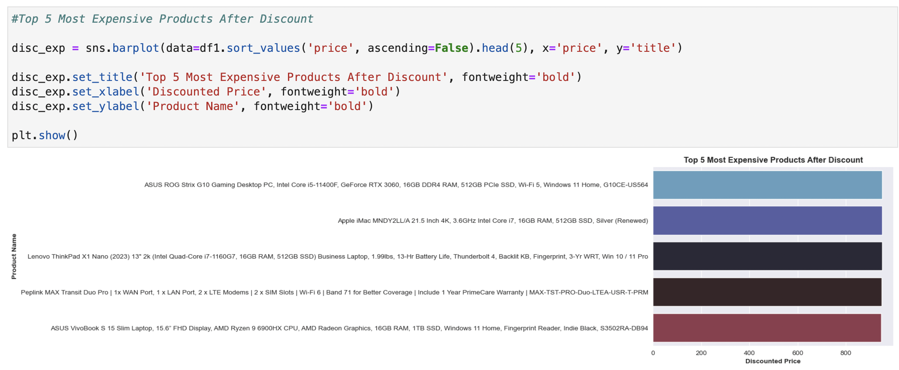

Fig: Top 5 Most Expensive Products After Discount

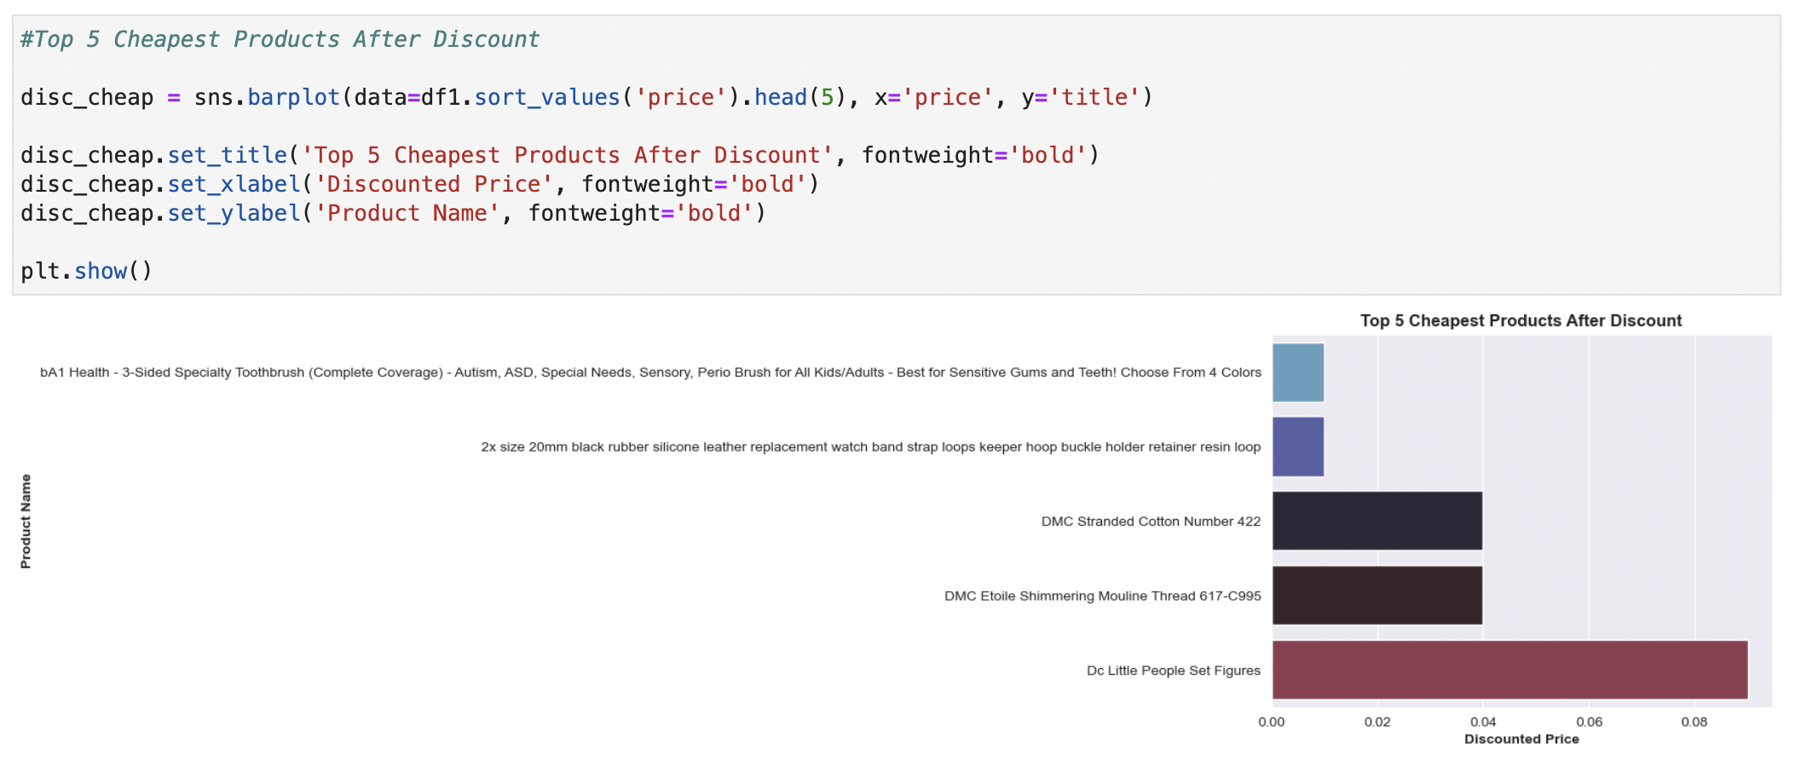

Fig: Top 5 Cheapest Products After Discount

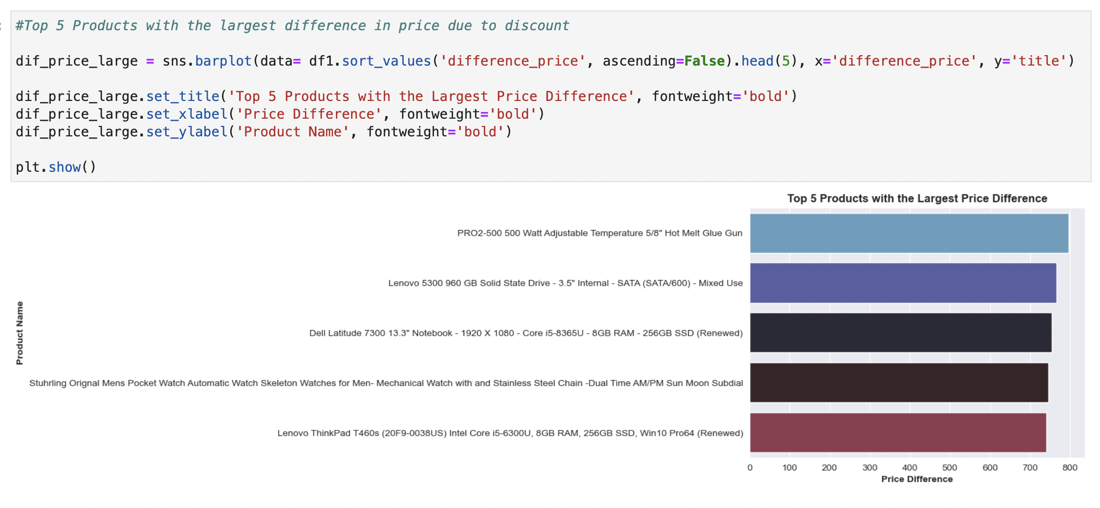

Fig: Top 5 Products with Large Price Difference

**Observation 2: Correlation between Features:**

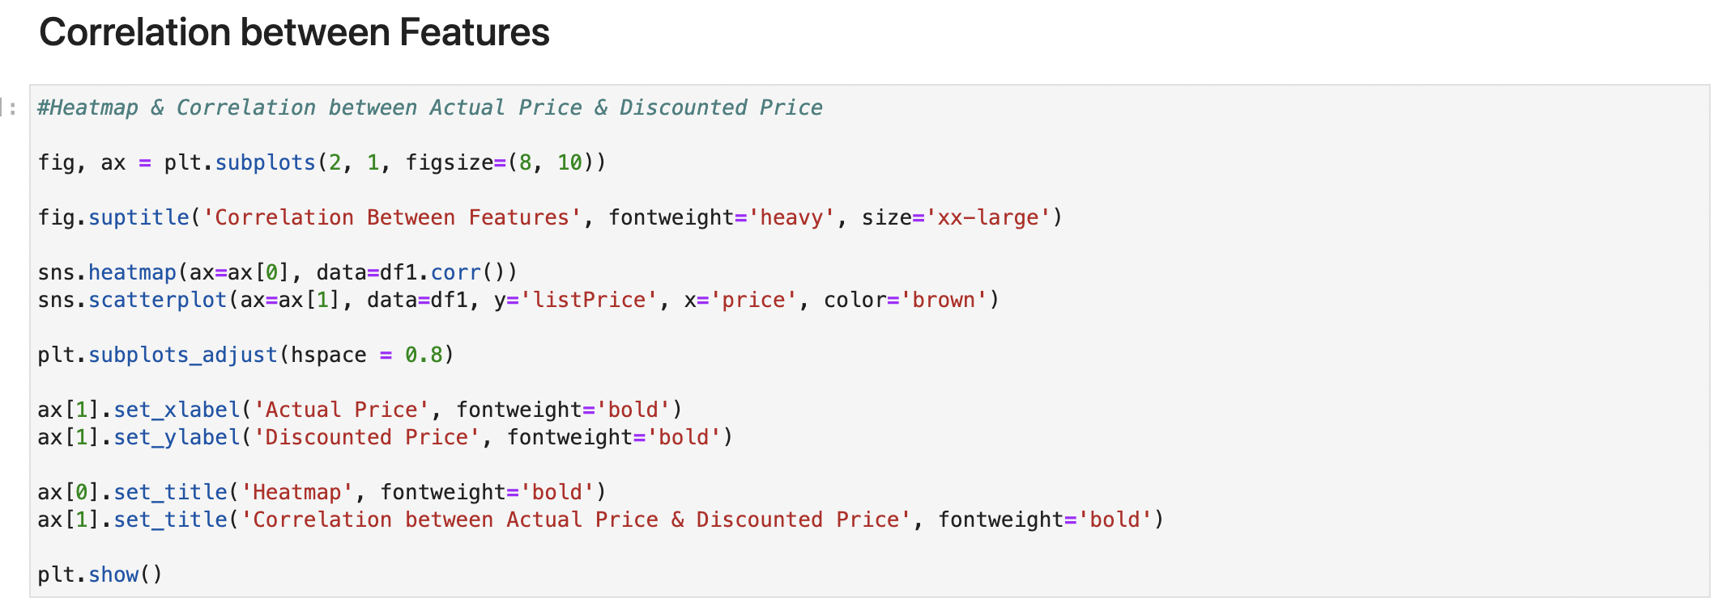

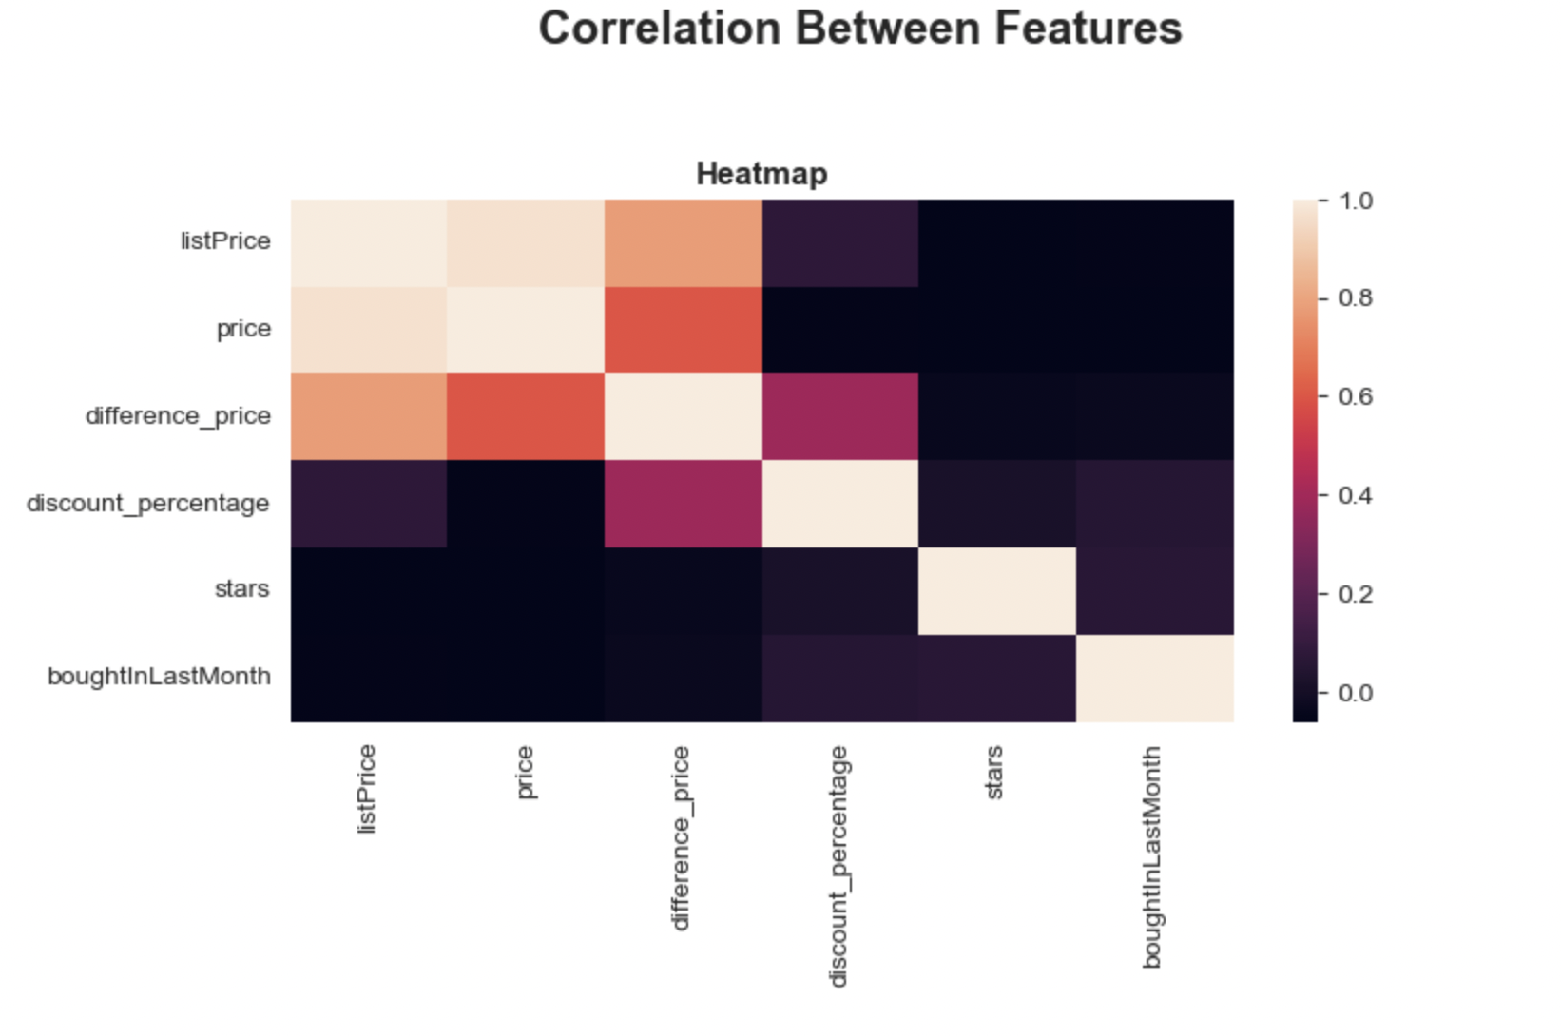

Fig: Heatmap showing correlation between various features

* 'listPrice' and 'price' have a strong negative correlation with 'discount_percentage'. This indicates that as the list price or the actual price of a product increases, the discount percentage tends to decrease, or vice versa.
* Positive correlation between 'listPrice' and 'price', which is expected as they are typically directly related. The 'difference_price', which might represent the difference between the list price and the actual price, is positively correlated with both 'listPrice' and 'price', suggesting that a higher price difference is associated with higher absolute prices.
* ‘boughtInLastMonth’ and ‘stars’ doesn’t show much correlation with other features.

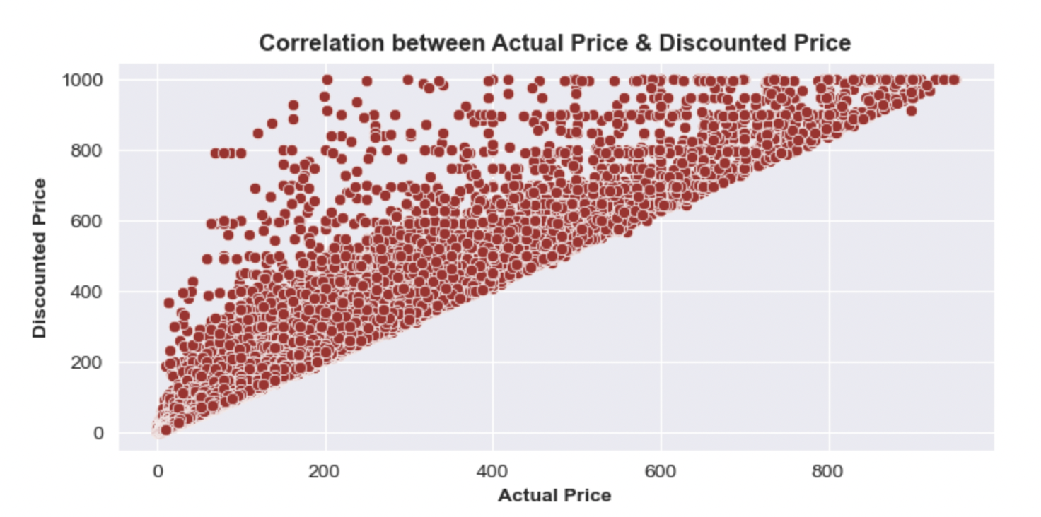

Fig: Scatter Plot showing correlation between price and listPrice

* There's a clear positive correlation between the actual price and the discounted price, indicating that as the actual price increases, the discounted price tends to increase as well suggesting they have linear relationship.
* There are some outliers, particularly in the higher price ranges. These could represent more expensive items or items with large discounts.

**Observation 3: Product Ratings**

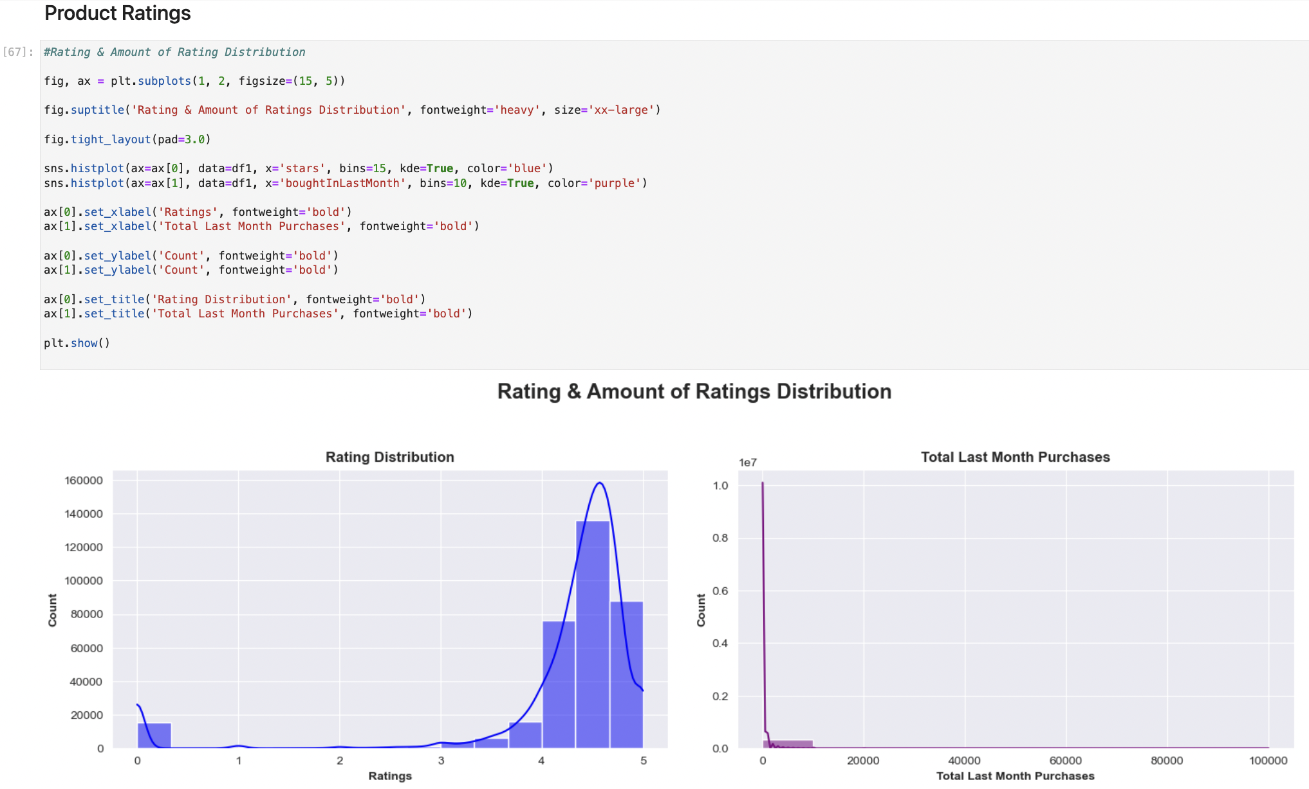

* High ratings are common among the products analyzed, while the number of purchases varies widely, with most products being purchased infrequently.

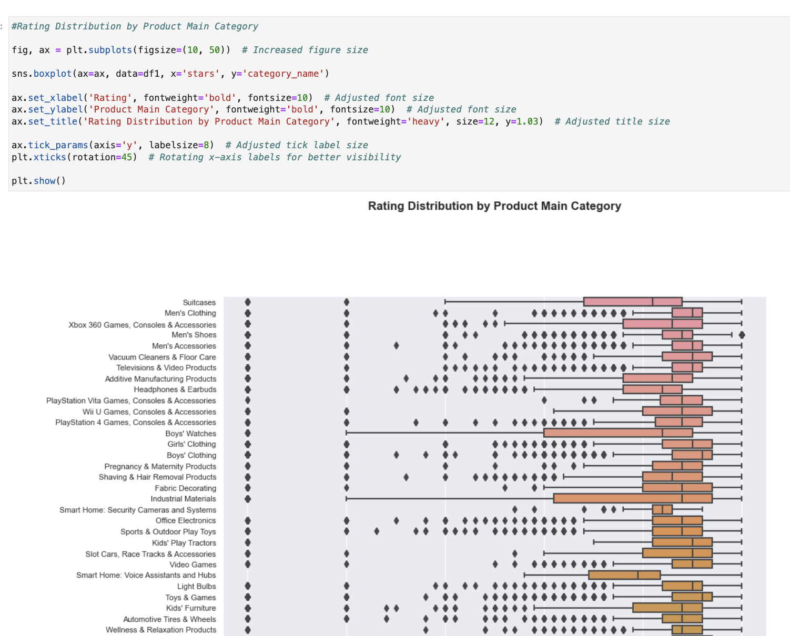

Fig: Boxplot Rating Distribution by Product Main Category

* Some categories have a symmetric distribution of ratings, while others are either towards higher or lower ratings.

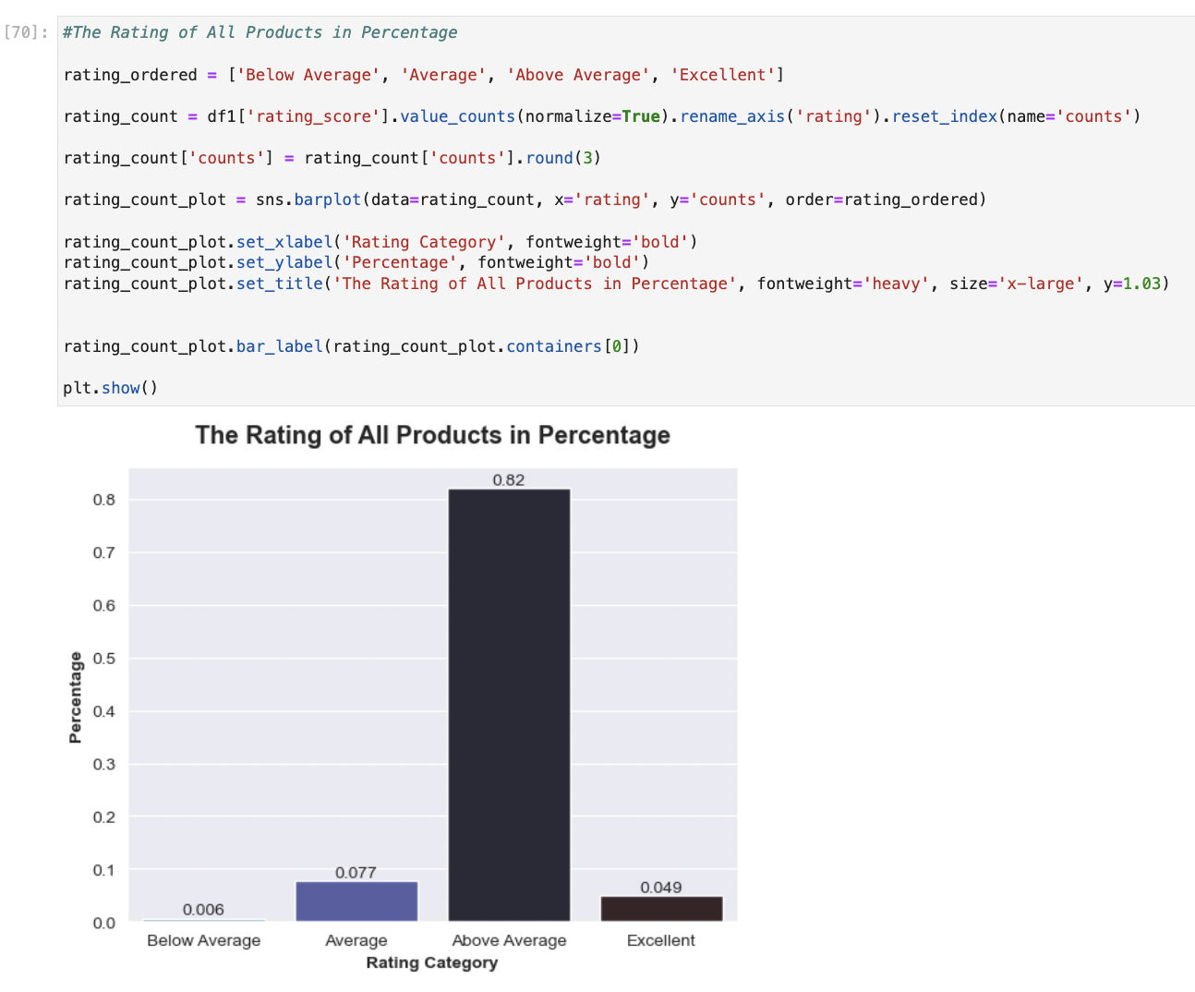

Fig: Barplot showing percentage of Rating Category Distribution

* From the bar plot, we can observe that the majority of the products fall into the 'Above Average' category, making up 82% of the total, indicating a generally positive rating trend across all products. The 'Excellent' category has a smaller, yet significant, proportion of 4.9%. The 'Average' category represents 7.7% of the products, and the 'Below Average' category is very small, at only 0.6%.

**Observation 4: Product Pricing**

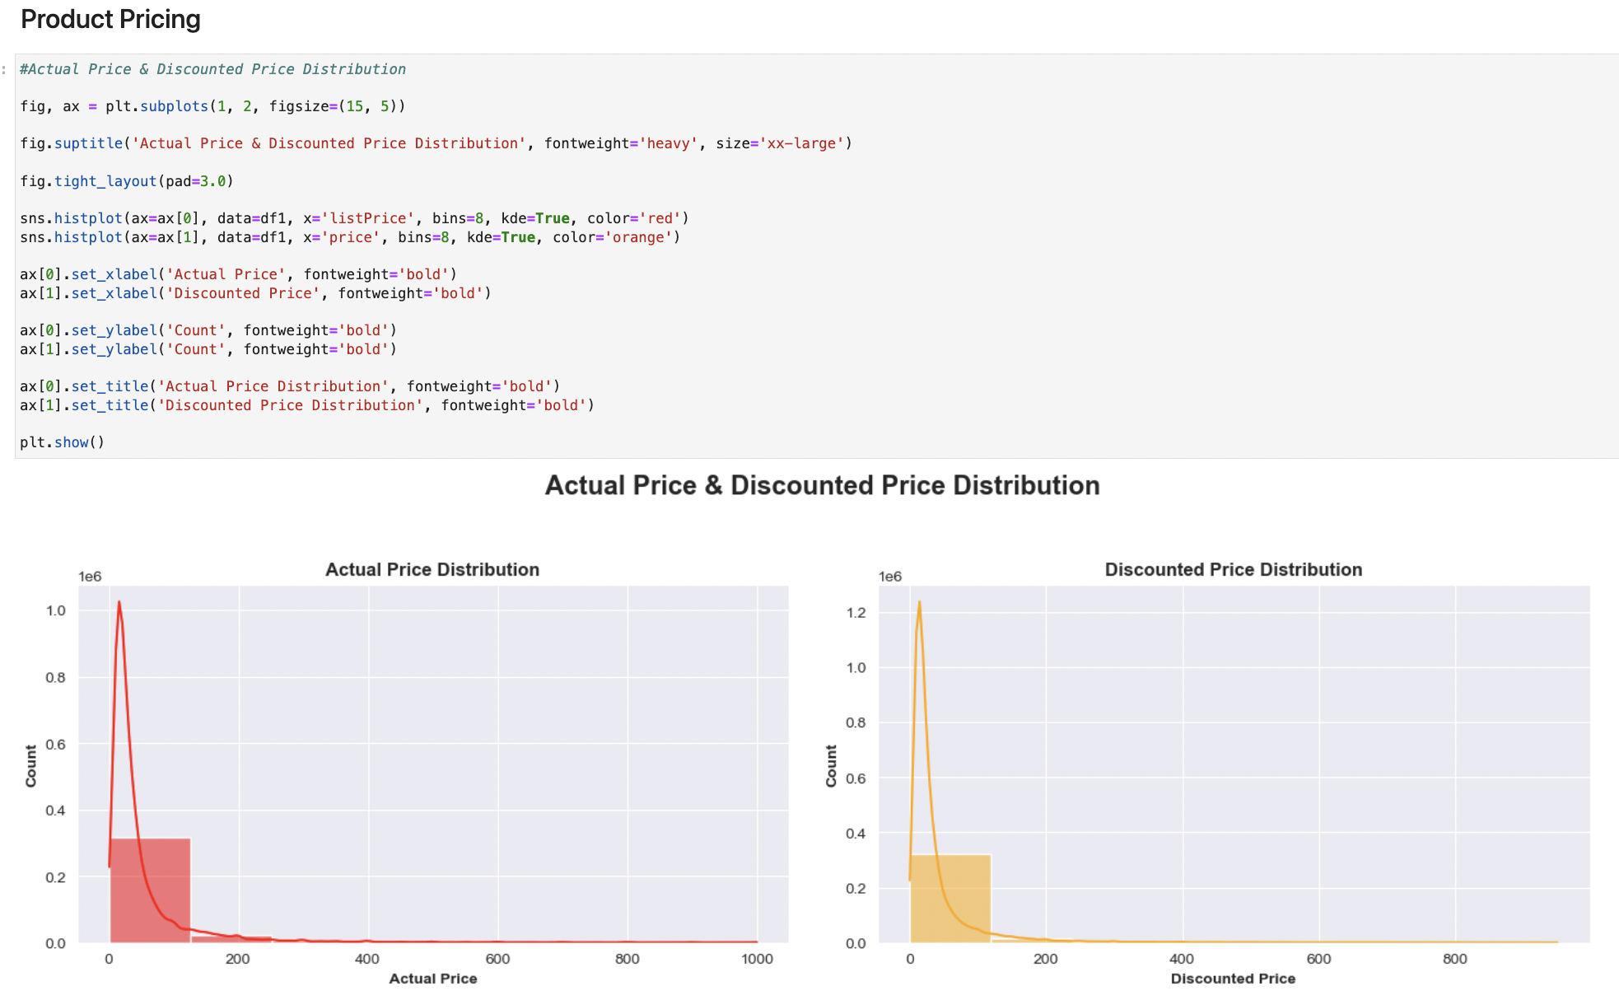

Fig: Histograms showing Actual Price and Discounted Price Distribution

* The left plot, distribution appears right skewed, indicating that while most of the products have lower actual prices, there's a long tail of products extending towards higher prices. This tail suggests that a smaller number of products are significantly more expensive than the rest.
* The right plot also seems right skewed, but with a sharper peak at the lower end of the price range. This peak indicates that a substantial proportion of products are being sold at lower discounted prices.

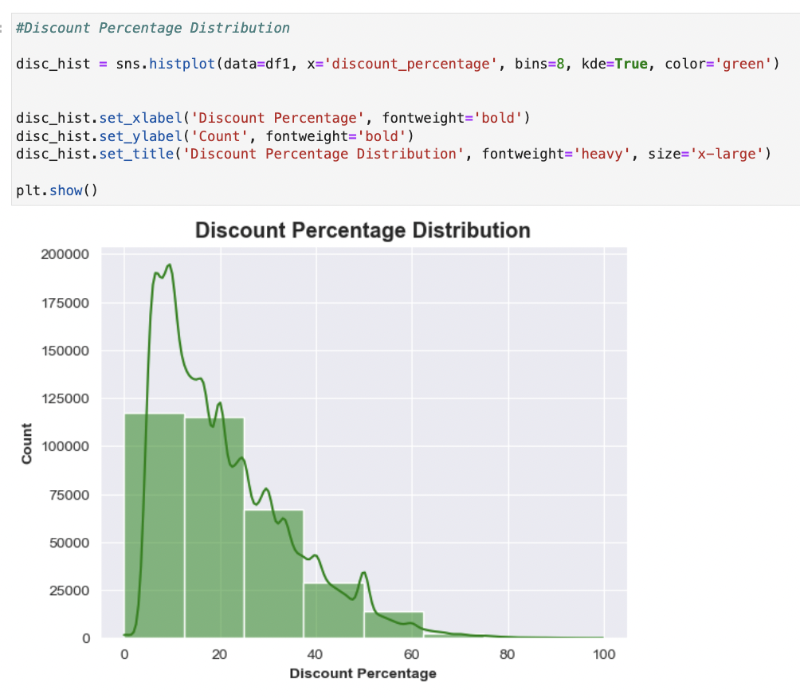

Fig: Histogram showing Discount Percentage Distribution

* The histogram shows that the distribution of discount percentages is skewed to the right. This suggests that most products receive a smaller discount, with fewer products receiving a higher percentage discount.

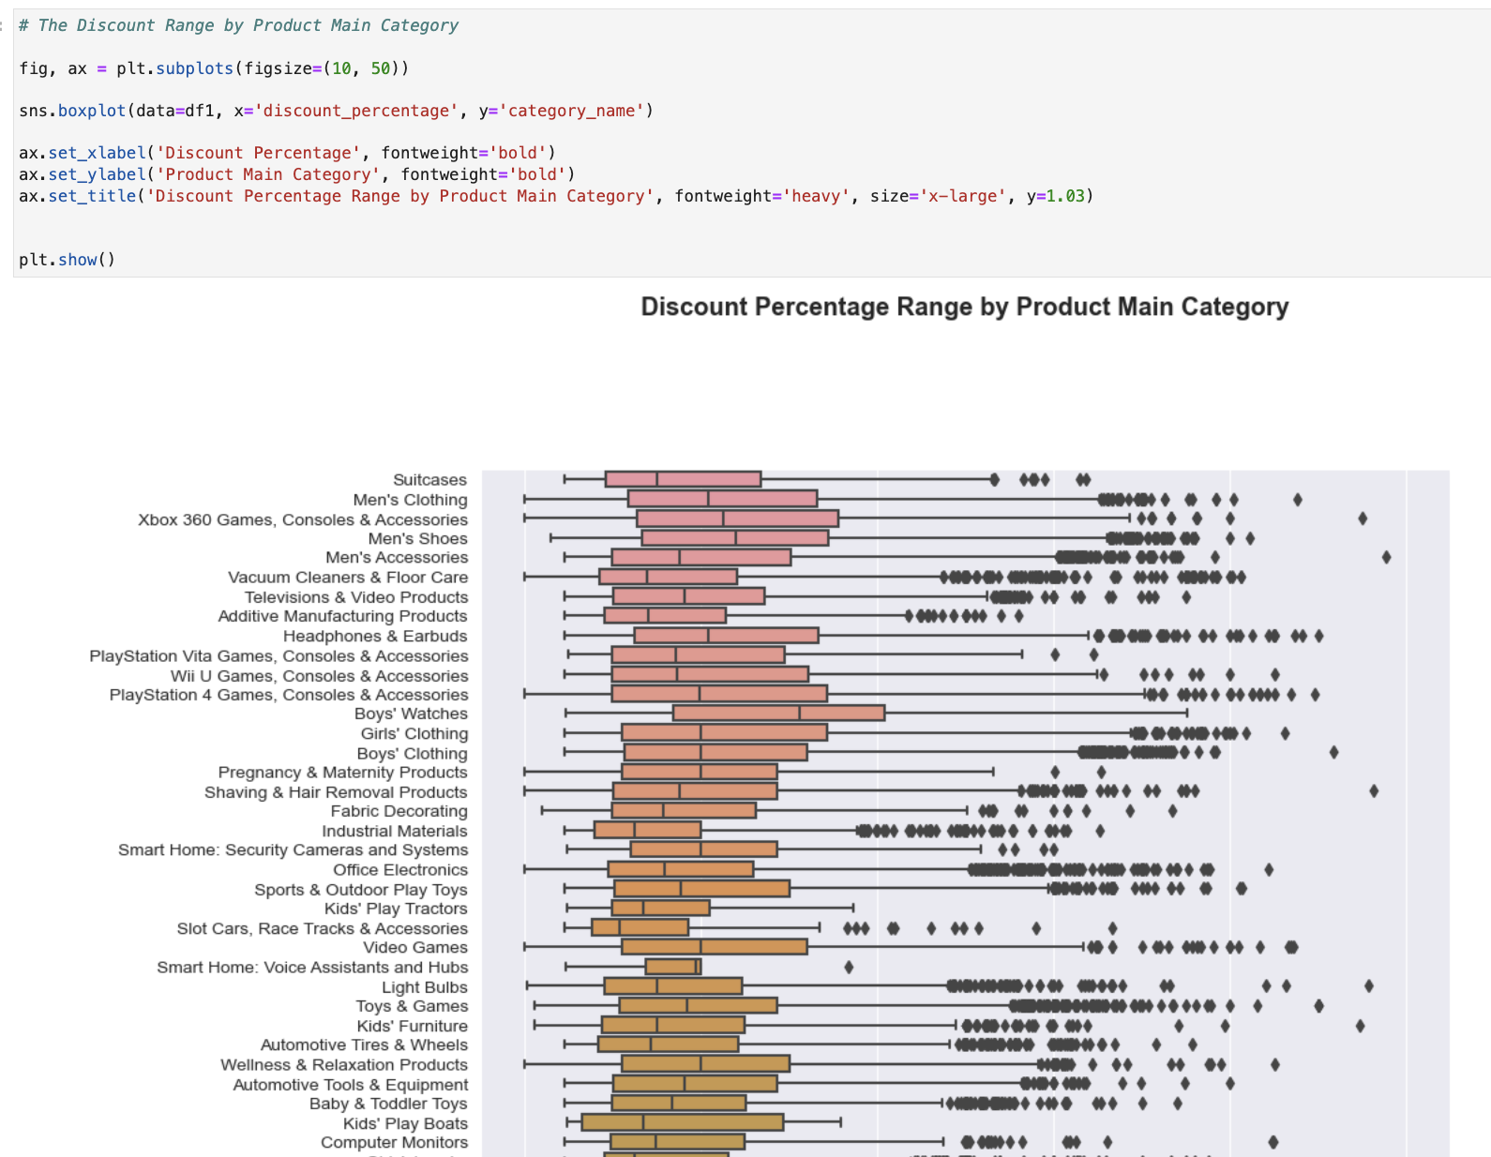

Fig: Boxplot showing Discount Percentage across Categories

* Most products receive a smaller discount, with fewer products receiving a higher percentage discount.
* There is a presence of. Individual points beyond the whiskers indicating outliers with particularly high discounts that deviate from the typical discount range in the category.

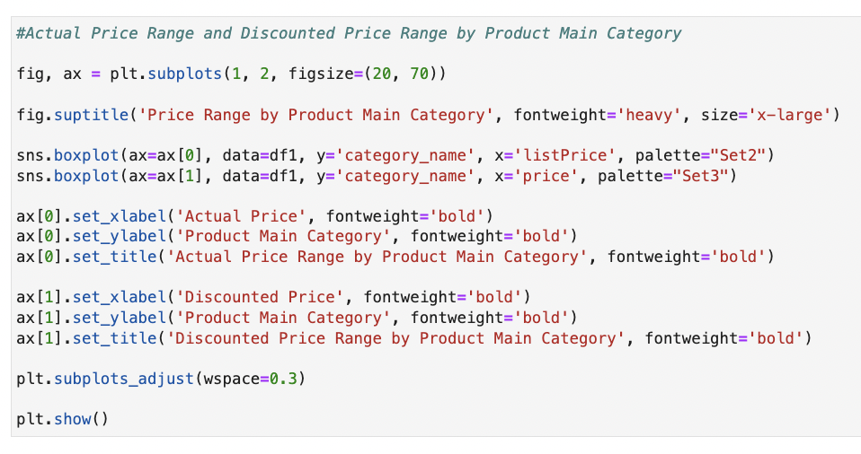

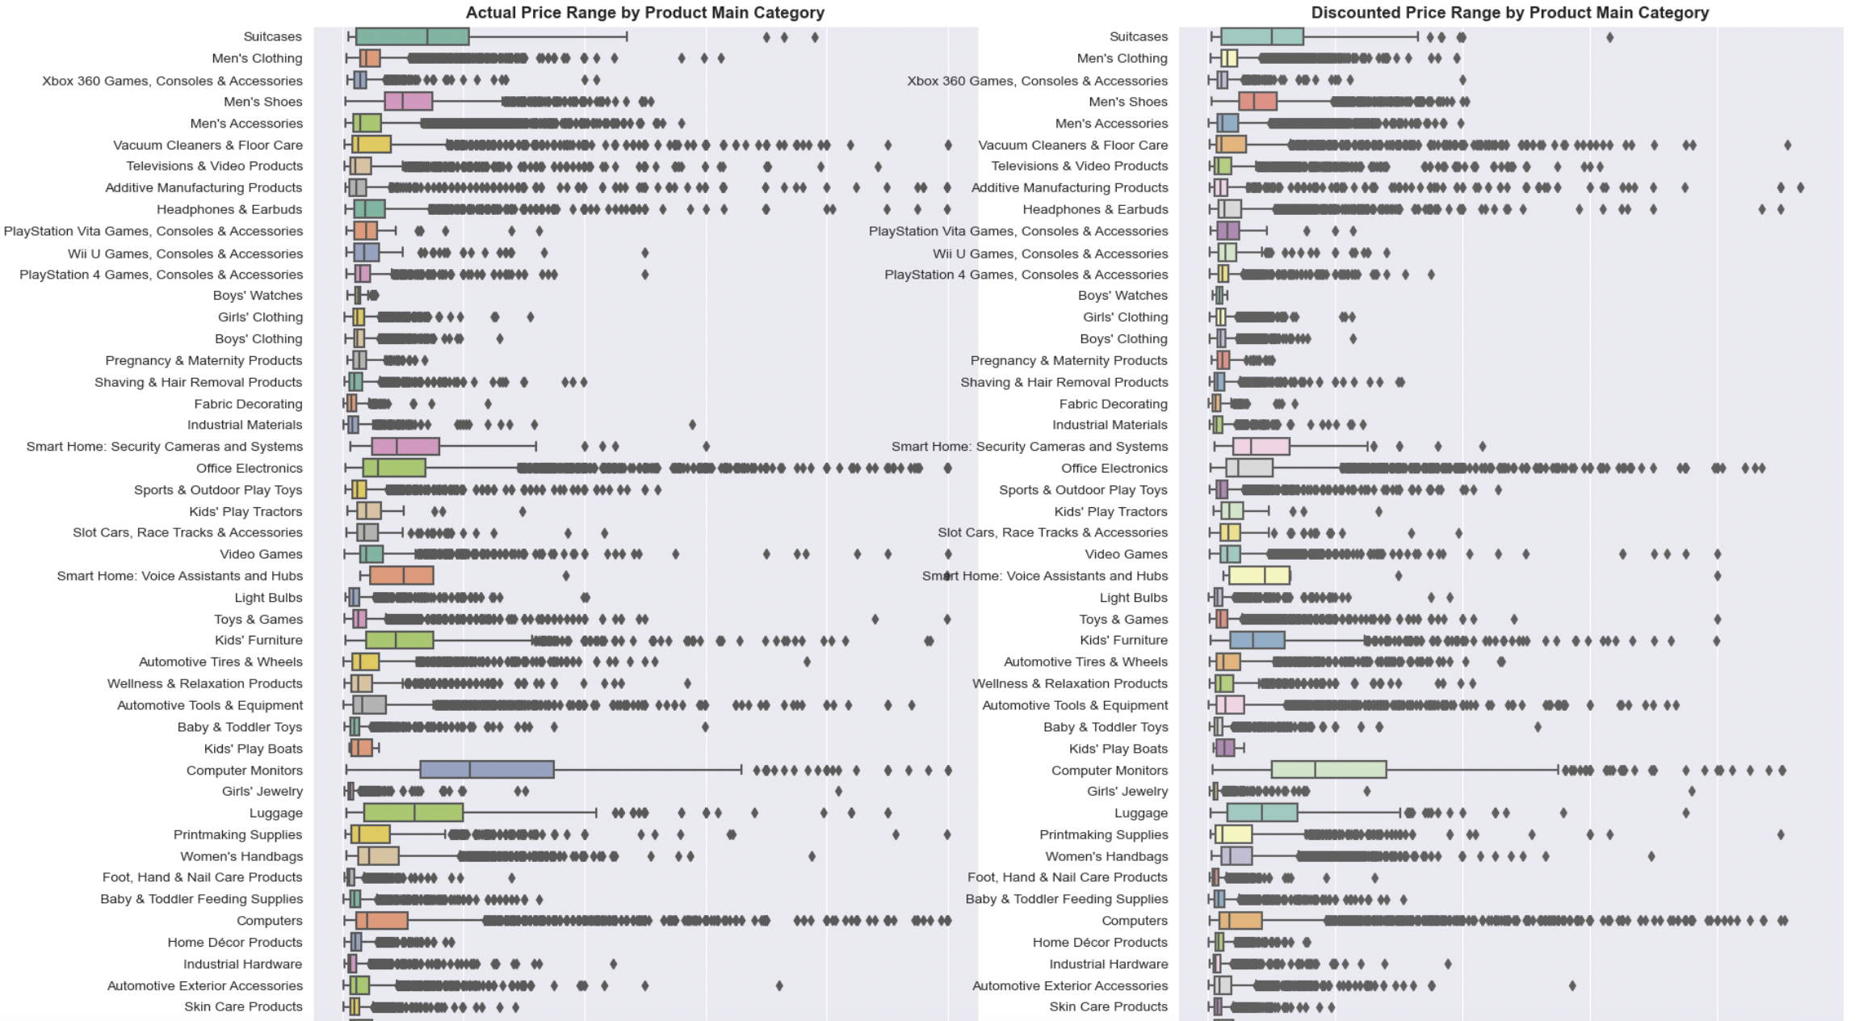

Fig: Boxplot showing Actual Price and Discounted Price range across categories

* Each chart would display the spread of prices within product categories. The left chart would show the range of actual prices, and the right chart would show the range after discounts are applied.
* Categories tend to have higher prices or discounts, and which have a more significant variation in prices.

1. **Machine Learning Model Training:** Machine learning models, including Regression Analysis, and Random Forest are used for prediction of discounted price of the products. Multinomial Naïve Bayes and Logistics Regression are used for sentiment prediction of products based on ratings.

All the models are using TF-IDF (Term Frequency-Inverse Document Frequency) and Count Vector as feature extraction methods from text data, which are common techniques in natural language processing (NLP) for tasks such as document classification or sentiment analysis. TF-IDF reflects how important a word is to a document in a collection, and Count Vector is a simpler approach that uses the frequency of words as features.

**Prediction of discounted price of products:**

* **Ridge Regression:**

Ridge Regression is primarily used to address the problem of multicollinearity in linear regression models. Multicollinearity occurs when predictor variables in a model are highly correlated. This situation can lead to unstable estimates of regression coefficients. Ridge Regression solves this by adding a penalty term to the regression equation, which shrinks the coefficients and reduces model complexity. The penalty term is the square of the magnitude of the coefficients, multiplied by a parameter (lambda or alpha) that controls the strength of the penalty. This regularization technique helps to prevent overfitting, ensuring that the model performs better on unseen data. The results after applying the model:

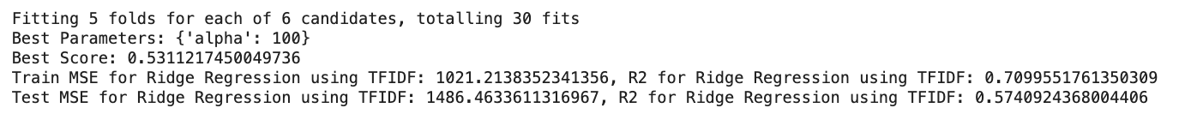

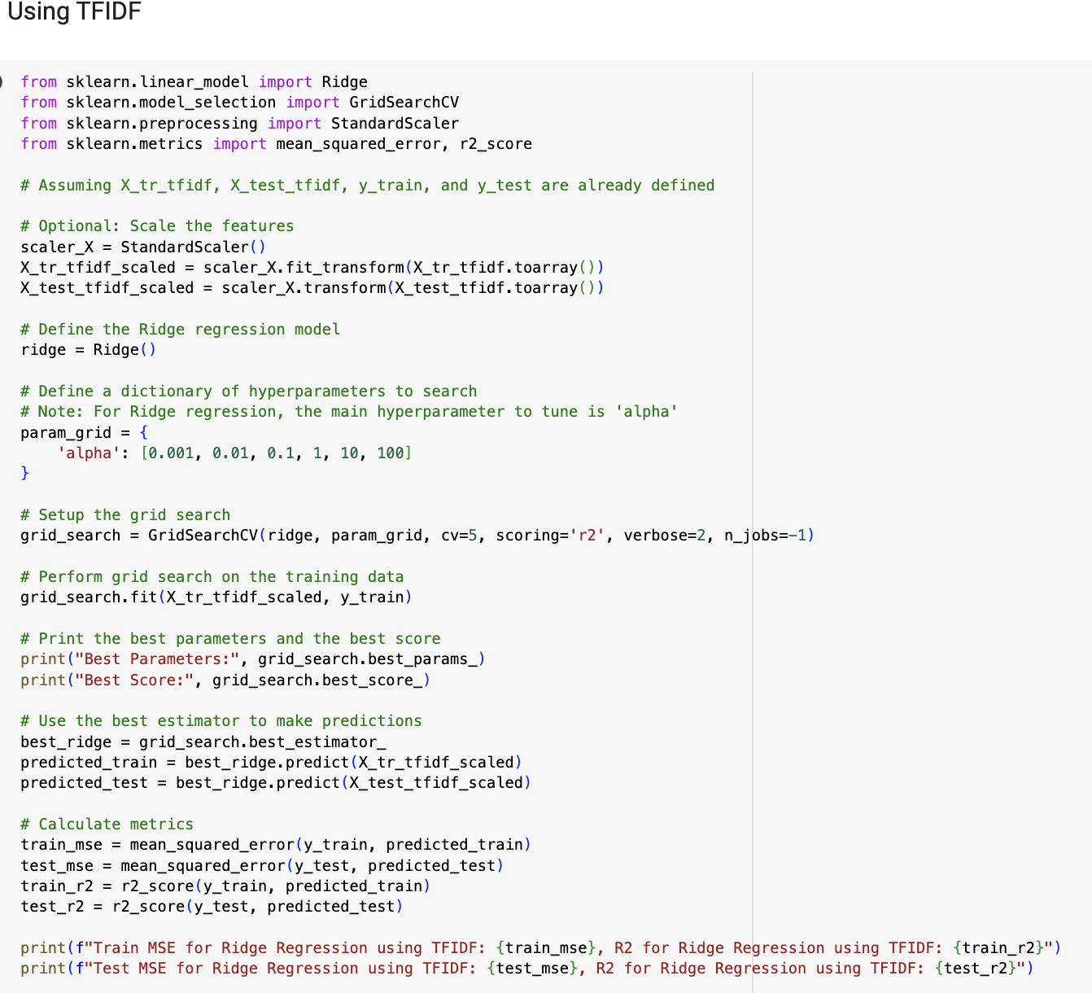

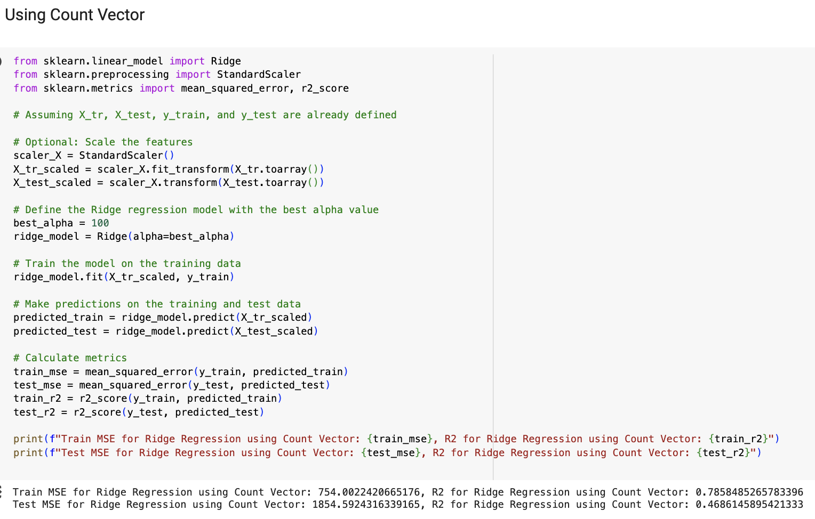

* **Random Forest Regressor:**

Next up we have applied Random Forest Regressor. Random Forest Regressor is used for regression tasks. It operates by constructing a multitude of decision trees during training and outputs the mean prediction of the individual trees. It is effective for a wide range of regression problems and is known for handling overfitting well. The results are as follows:

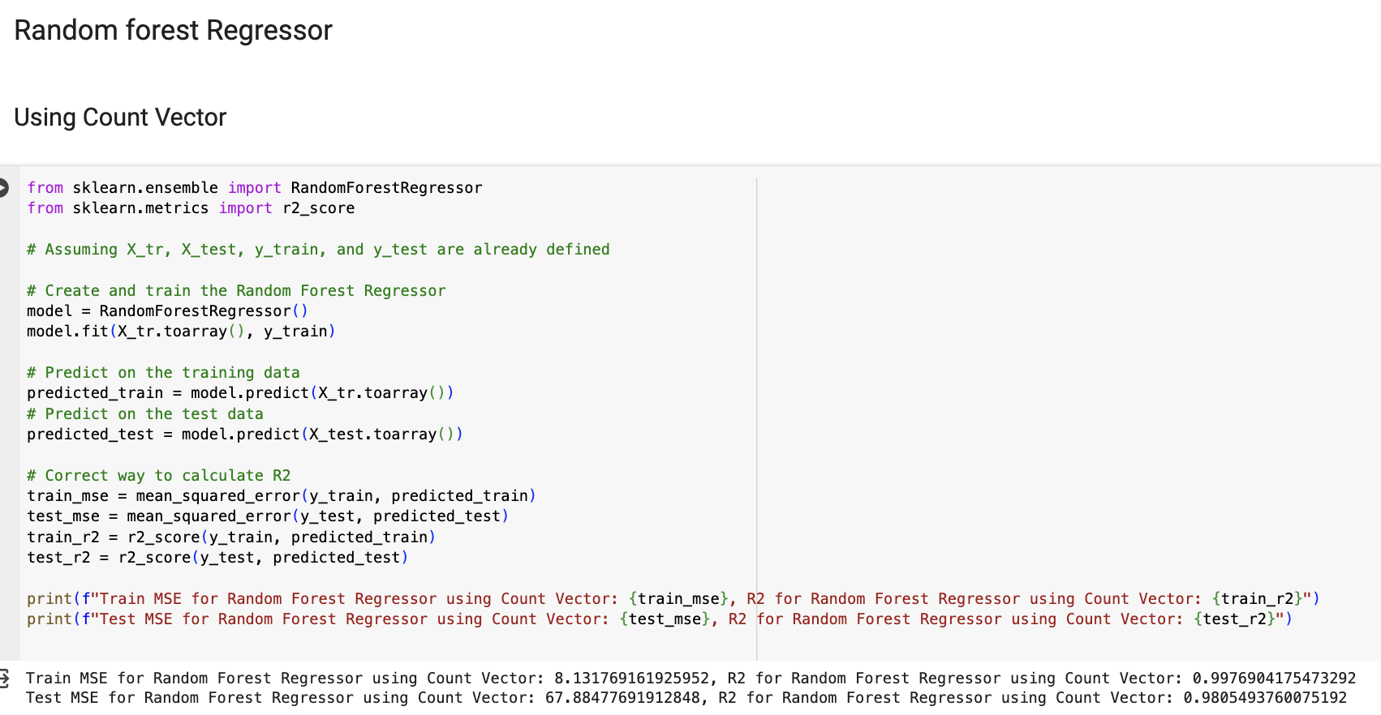

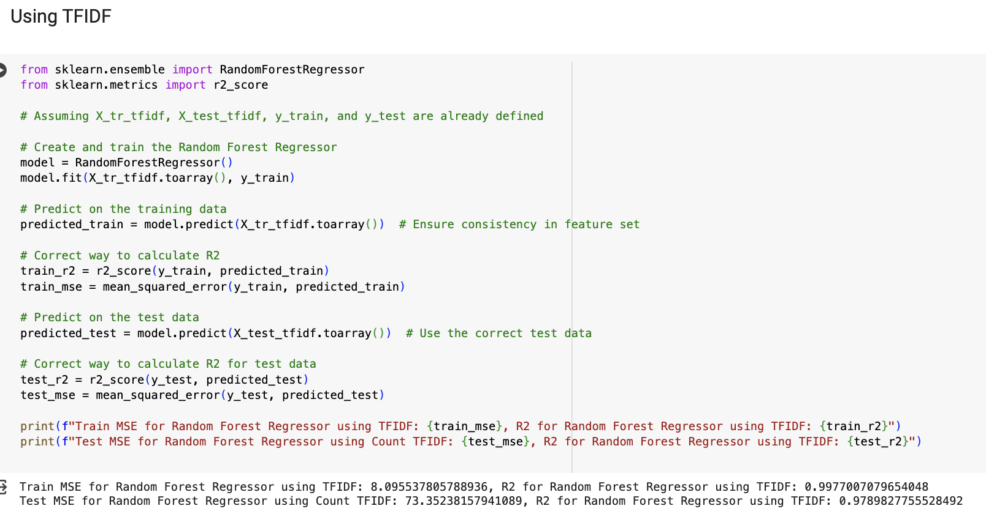

**Predicting Sentiment of Products based on Ratings:**

* **Multinomial Naïve Bayes:** MNB classifier is a probabilistic learning method commonly used in Natural Language Processing (NLP) for text classification tasks. It is based on the Bayes theorem and the 'naive' assumption of conditional independence between every pair of features given the value of the class variable. In both cases, the LabelEncoder is used to encode target labels with value between 0 and n_classes-1, which is necessary for the MNB classifier to understand the target variable. The results are as follows:

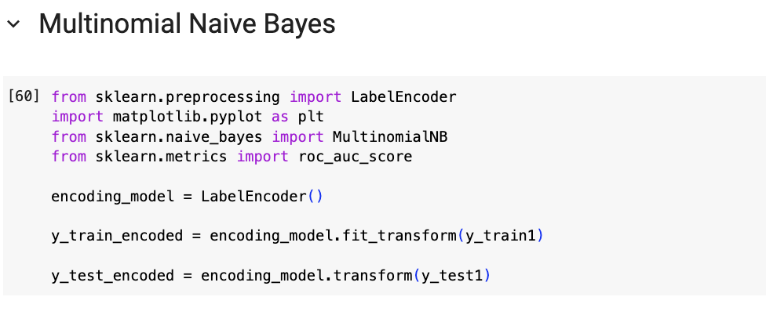

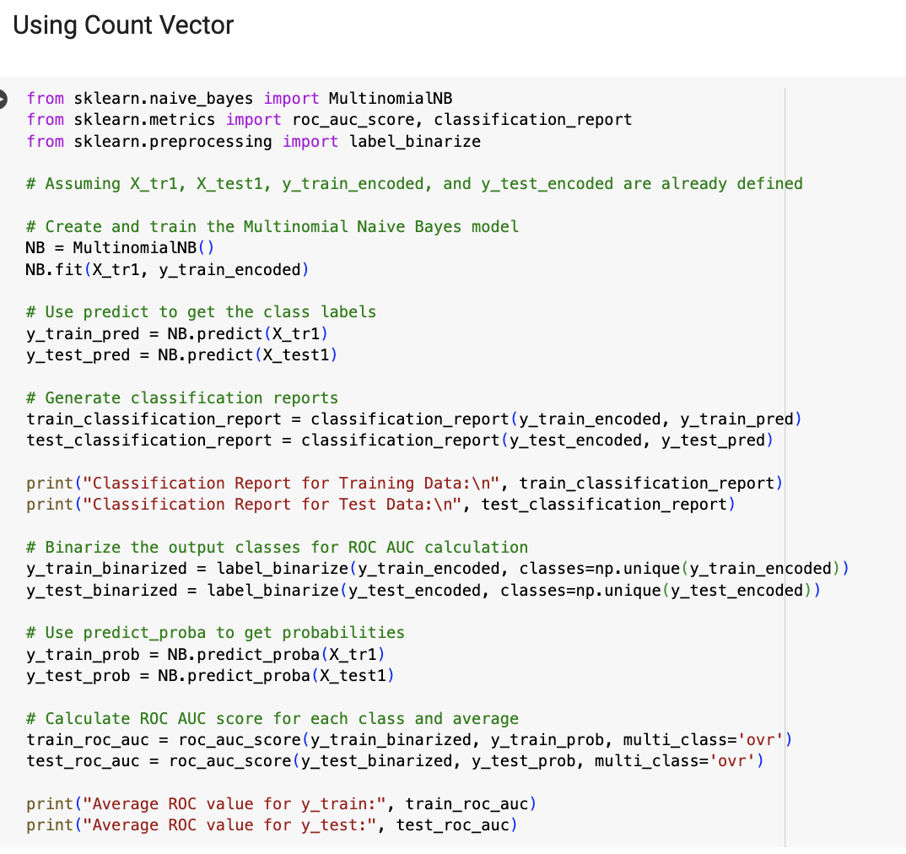

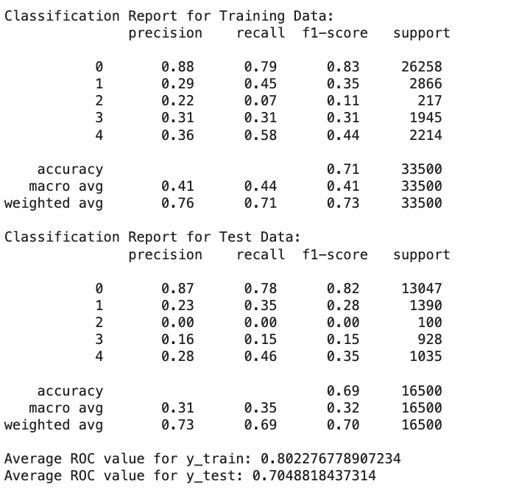

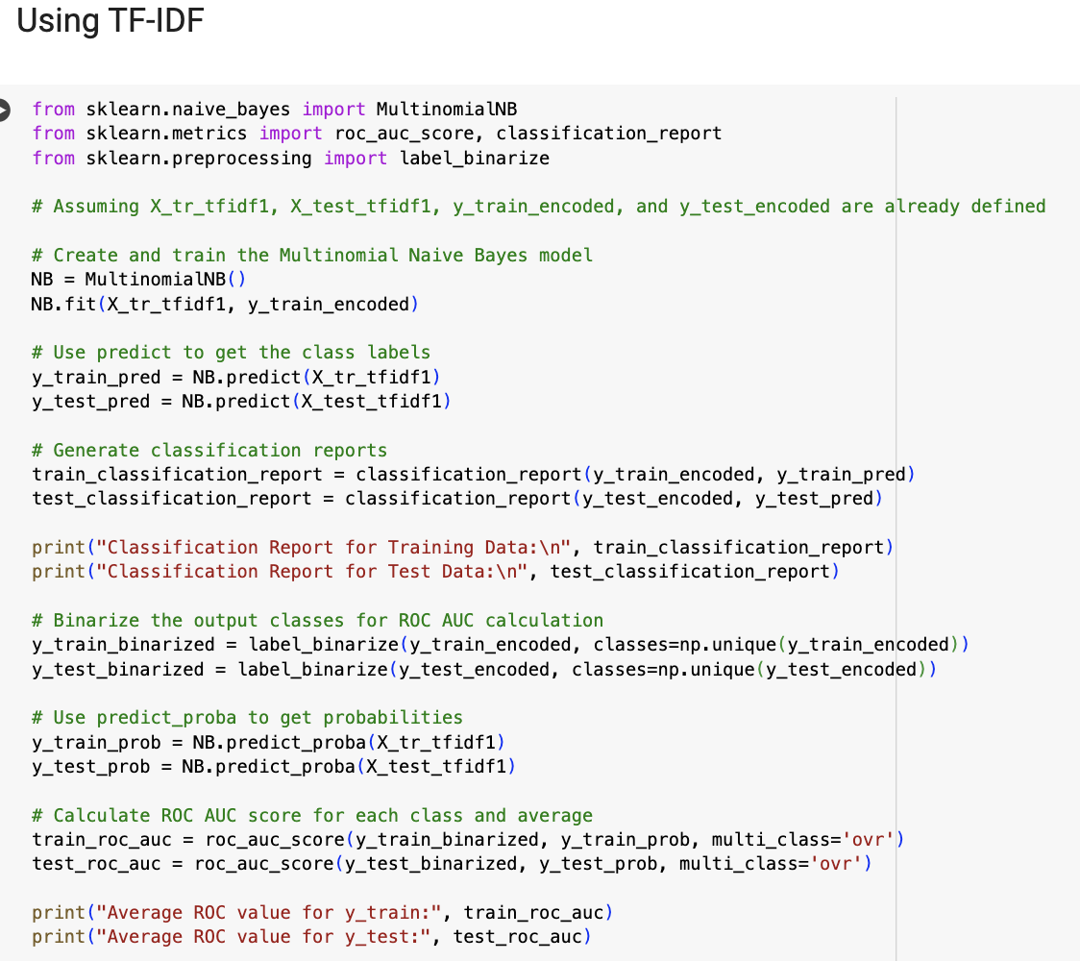

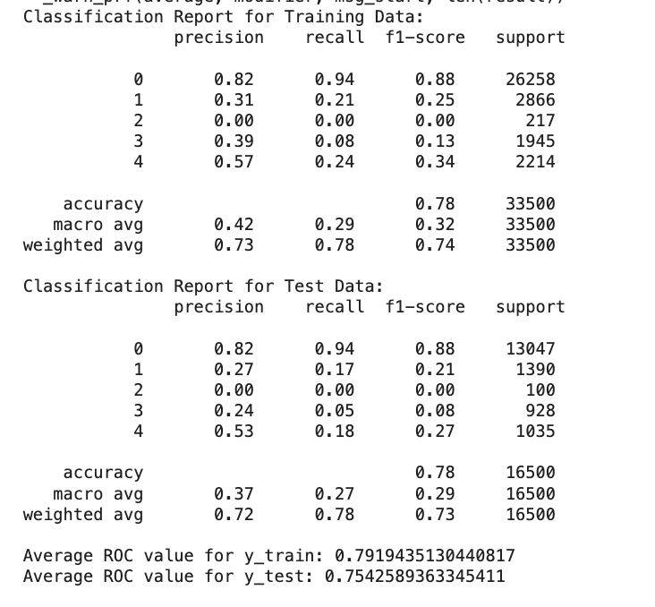

* **Logistic Regression:** It is a classification algorithm used when the response variable is categorical. The algorithm predicts the probability of the target variable belonging to each category. In the context of text classification, it can classify text into categories like spam or not spam, positive or negative sentiment, etc. The results are as follows:

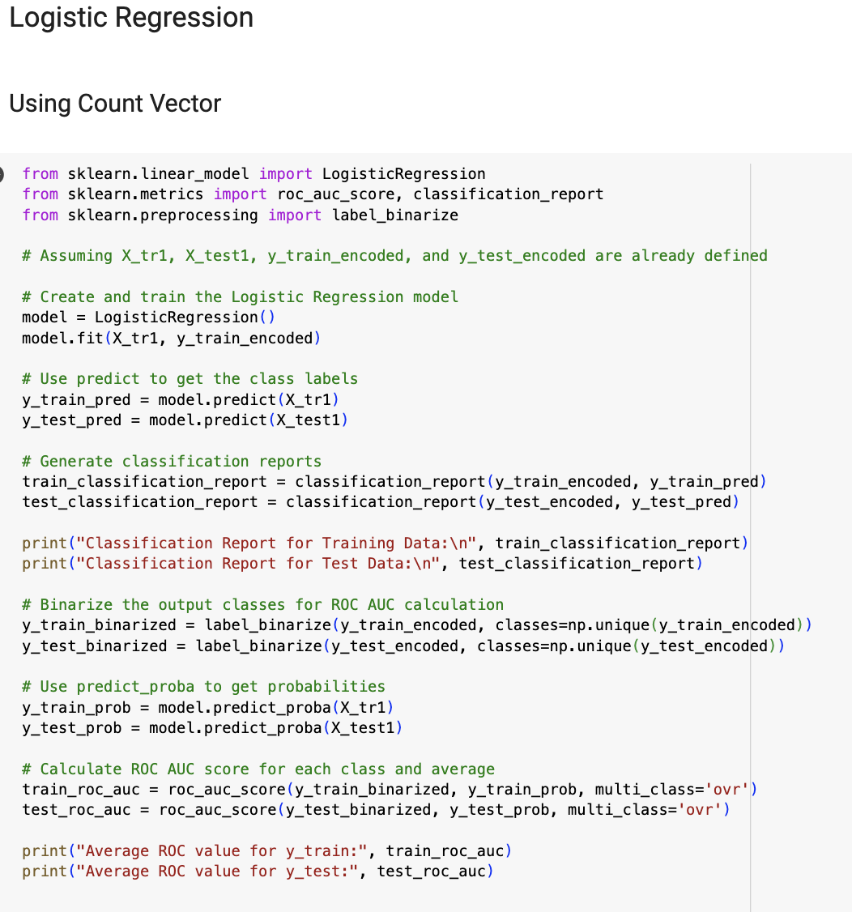

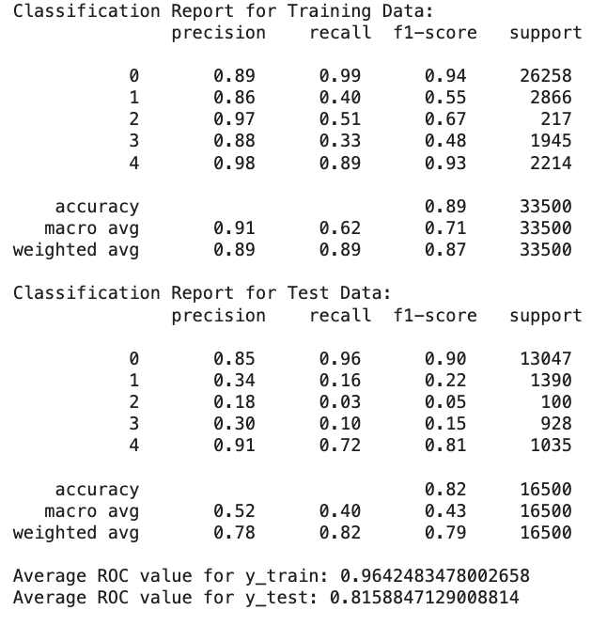

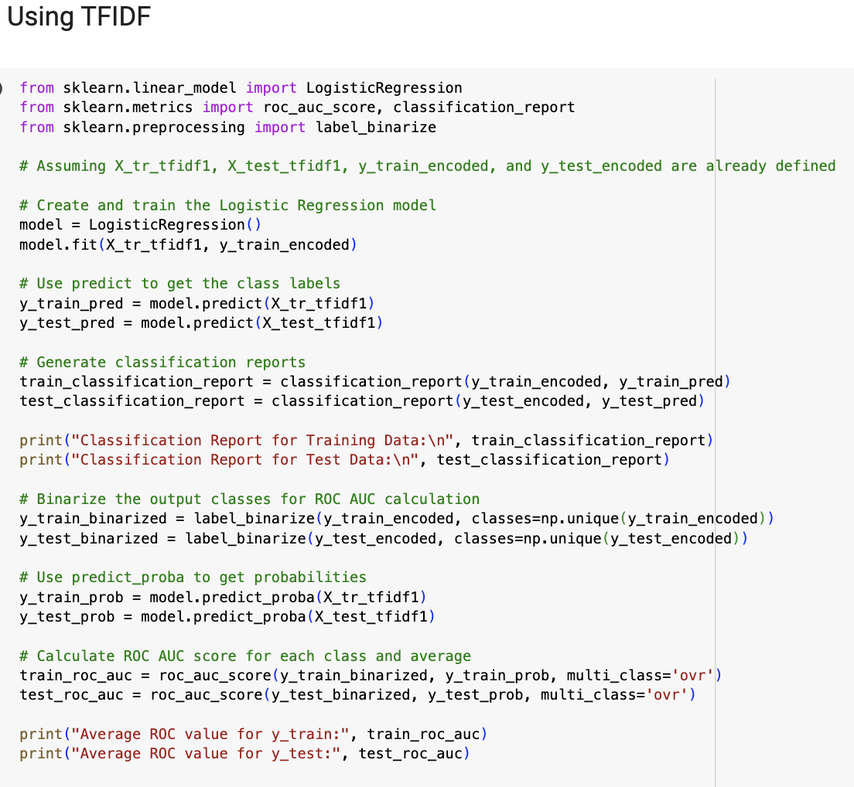

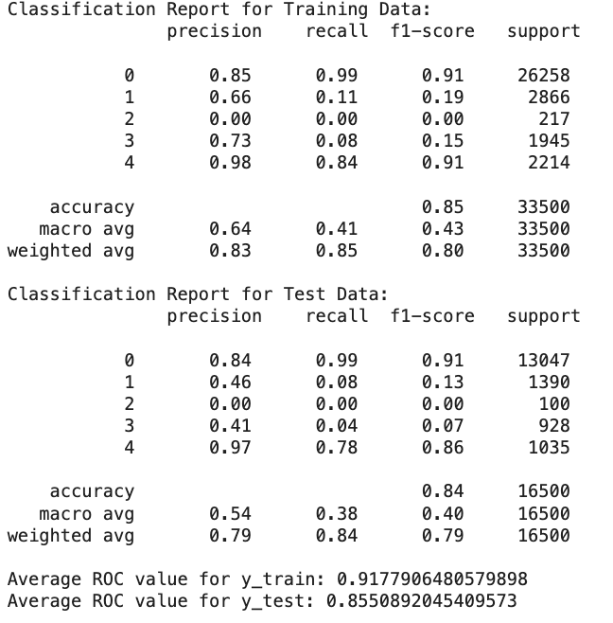

**Conclusion**

**Prediction of discounted price of products:**

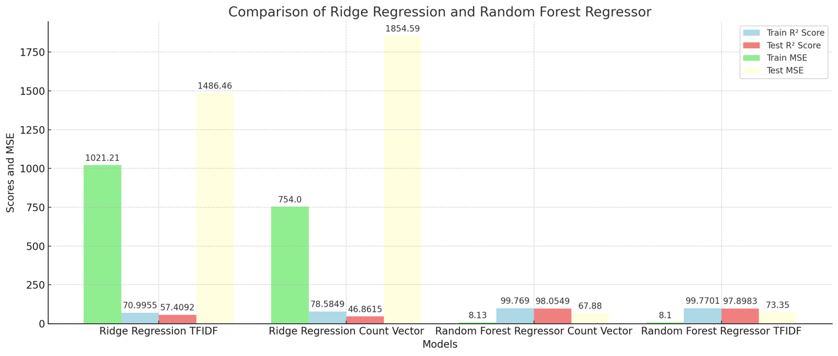

* **Ridge Regression**

1. **TFIDF Features:**

**Best Parameters:** Alpha = 100

**Best Score:** 0.5311

**Train MSE:** 1021.21, **Train R²:** 0.7100

**Test MSE:** 1486.46, **Test R²:** 0.5741

1. **Count Vector Features:**

**Train MSE:** 754.00, **Train R²:** 0.7858

**Test MSE:** 1854.59, **Test R²:** 0.4686

* **Random Forest Regressor**

1. **Count Vector Features:**

**Train MSE:** 8.13, **Train R²:** 0.9977

**Test MSE:** 67.88, **Test R²:** 0.9805

1. **TFIDF Features:**

**Train MSE:** 8.10, **Train R²:** 0.9977

**Test MSE:** 73.35, **Test R²:** 0.9790

**Observations:**

* The Random Forest Regressor significantly outperforms the Ridge Regression model in terms of Mean Squared Error (MSE) and R² (Coefficient of Determination) for both training and testing sets, regardless of the feature extraction method used.
* Ridge Regression shows higher MSEs, indicating less accurate predictions compared to Random Forest.
* For both models, the choice between TFIDF and Count Vector features seems to affect the performance, but the impact is more pronounced in the Ridge Regression model. The Ridge Regression model performs better with Count Vector on the training set but worse on the test set, suggesting that TFIDF might be a better choice for generalization.
* For critical applications on this dataset, Random Forest should be considered due to its superior performance metrics. However, for applications where computational efficiency is key, Ridge Regression might be more suitable despite its lower accuracy.

**Predicting Sentiment of products:**

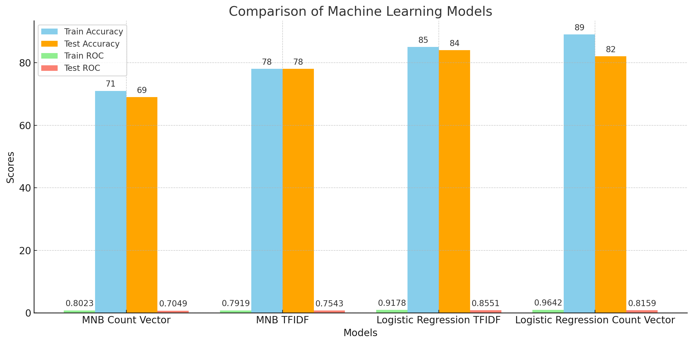

* **Multinomial Naive Bayes**

1. **Using Count Vector:**

**Training Data Performance:** Accuracy of 71%, with precision, recall, and F1-score varying significantly across classes.

**Test Data Performance:** Accuracy of 69%, with generally lower precision, recall, and F1-scores compared to training data.

**Average ROC Values:** 0.8023 (Train), 0.7049 (Test).

1. **Using TFIDF:**

**Training Data Performance:** Accuracy of 78%, higher than with Count Vector.

**Test Data Performance:** Accuracy of 78%, consistent with training data.

**Average ROC Values:** 0.7919 (Train), 0.7543 (Test).

* **Logistic Regression**

1. **Using TFIDF:**

**Training Data Performance:** Accuracy of 85%, higher than MNB.

**Test Data Performance:** Accuracy of 84%, indicating good generalization.

**Average ROC Values:** 0.9178 (Train), 0.8551 (Test).

1. **Using Count Vector:**

**Training Data Performance:** Accuracy of 89%, higher than MNB and Logistic Regression with TFIDF.

**Test Data Performance:** Accuracy of 82%, slightly lower than training but still high.

**Average ROC Values:** 0.9642 (Train), 0.8159 (Test).

**Observations:**

* Logistic Regression shows a more consistent performance between training and test data compared to MNB, suggesting better generalization capability.
* Logistic Regression tends to have higher precision, recall, and F1-scores, especially with Count Vector. This indicates a stronger capability in correctly classifying different classes, particularly in multiclass settings.
* The choice of feature extraction method (Count Vector vs. TFIDF) affects the performance of both models. Logistic Regression benefits more from the Count Vector method, while MNB shows relatively less variation in performance between the two methods.
* Given its overall superior performance, Logistic Regression appears to be a more robust and accurate model for this particular text classification task.

**References**

[1] Kaggle Notebook: <https://www.kaggle.com/code/alancano/amazon-products-2023>

[2] Kaggle Notebook: <https://www.kaggle.com/code/dima806/amazon-price-discount-autoviz-catboost-shap>

[3] TF-IDF Documentation: <https://scikit-learn.org/stable/modules/generated/sklearn.feature_extraction.text.TfidfVectorizer.html>

[4] TF-IDF: <https://medium.com/@cmukesh8688/tf-idf-vectorizer-scikit-learn-dbc0244a911a>

[5] Count Vectorizer Documentation: <https://scikit-learn.org/stable/modules/generated/sklearn.feature_extraction.text.CountVectorizer.html>